# Design Overview for Custom project

Name: Hoang Minh Khue

Student ID: 104221423

# Summary of Program

* In this project, I am intending to make a 2D shooter game. There will be a player, which can move to the right or left, jump, and shoot out bullets from its gun. There will be enemies for the player to shoot at. For every enemy killed, the player earns some score.
* A screenshot of what the game will look like.

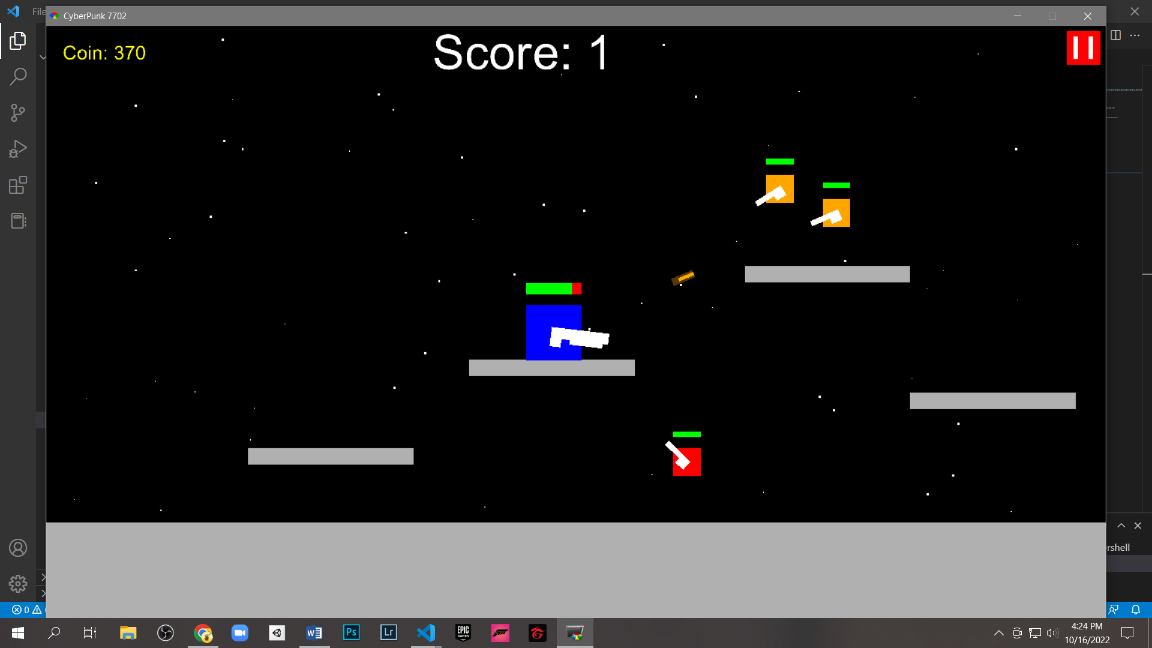

# Required Data Types

Describe each of the records and enumerations you will create using the following table (one per record).

Table : @player details

|  |  |  |
| --- | --- | --- |
| Field Name | Type | Notes |
| @player | Object | Create a player |

Table 2: @enemy details

|  |  |  |
| --- | --- | --- |
| Field Name | Type | Notes |
| @enemy | Array | Create an array of enemy object |

Table 3: @bullet details

|  |  |  |
| --- | --- | --- |
| Field Name | Type | Notes |
| @bullet | Array | Create an array of bullet object |

Table 4: @ground details

|  |  |  |
| --- | --- | --- |
| Field Name | Type | Notes |
| @ground | Array | Create an array of ground object |

# Overview of Program Structure

Main function needed:

* Main function: Keeps track of player score, best score, coin, and the gameplay; saves and recalls user data.
* Game function: Creates player, enemies, and grounds; keeps track of player’s death, enemies’ death, and bullets.
* Player function: Get user inputs to perform actions.
* Enemies function: Control enemies’ behaviour
* Bullet function: Control bullets’ behaviour.

Structural chart:

